


ECONOMICS OLYMPIAD – NATIONAL ROUND TEST

Name and Surname__________________________ School/CIty____________________________
Total points _________________

Test instruction:
Welcome to the national round of economics olympiad!
Content: Please read the test instructions carefully: The test has a total of 14 questions and is divided into four parts:
Part I: Multiple choice questions: in this part of the test you have to choose only one correct answer.
Part II: Quantitative or numerical questions: for this part you may need a calculator or make additional calculations. Based on the result you get, you have to answer the sub-questions of this session.
Part III: Questions with graphs: In this part you have to analyze the presented graph and answer the questions presented by interpreting the graph.
Part IV: Essay questions: In this part you have to write short essay on the given topic. Please write clearly and be concise in content using your personal and original knowledge.
Duration: The test lasts 2 hours. During the test, the use of telephones and communication in any form with colleagues or access to technological devices (phone, tablet and computer) is prohibited.
Copying and plagiarism: In case of copying or plagiarism of any kind you will be forced to leave the test and be disqualified from the competition at the national and international level. The use of the toilet is not recommended during the test but is allowed in exceptional cases.
For any question or uncertainty during the test, please raise your hand and one of the test administrators will help you.
Declaration of consent for the use of personal data (GDPR)
I agree that my personal data (first name, last name) will be used only for identification purposes during testing by professors but not by third parties. ☐
I agree that the photos and videos from this competition will be used for the purposes of promotion of the competition and as marketing material for the official channels of EFI NM and LAI. ☐

We wish you success!

PART 1 – MULTIPLE CHOICE QUESTIONS (10 x 2 points = 20 points)

- What does the concept of "elasticity of demand" measure”?
- The responsiveness of quantity demanded to changes in price.
- The total demand for a good or service in the market.
- The proportion of income spent on a particular good.
- The ability of consumers to substitute one good for another..

- What is the main function of a central bank in an economy?
- Fiscal policy implementation.
- Regulation of banking sector
- Control over government spending.
- All of the above.

- If the price is greater than the marginal cost of producing a good, the seller has?
- Some negative consumer surplus from the sale.
- Some producer surplus from the sale.
- A loss.
- No benefit from the sale.
- None of the above answers is correct.

- Which of the following is not associated with the economic problem?
  - Inefficiency.
  - Pollution.
  - Sustainability.
  - Inequality.

- Which of the following is a strength of a market economy?
- There will be greater productivity than in a command economy.
- There will be greater equality of income than in a mixed economy.
- There will be greater equality of income than in a mixed economy.
- There will be greater provision of public goods than in a command economy.

- Which of the following best describes the function of a price ceiling:
  - To establish a minimum price for a good.
  - To prevent prices from rising above a certain level.
  - To encourage market competition.
  - To regulate the quality of goods and services.

- Which of the following is a benefit of specialisation and division of labour?
  - Greater worker satisfaction.
  - Increased allocative efficiency.
  - Greater income equality.
  - Increased productivity.

- Banks create money by
- Buying government bonds
- Printing currency
- Making loans
- Lending to the Central Bank.

- Two brands of water, "Maya" and "Izvorska", are close substitutes. If the price of "Izvorska" decreases, the price drop:
  - Increases the demand for "Izvorska".
  - Increases the "Maya" price.
  - Shifts the demand curve for "Maya" to the left.
  - Shifts the demand curve for "Maya" to the right.
  - More information is needed to determine whether the demand curve for "Maya" shifts to the right or to the left

- Mary has decided that she doesn't like Germany and has decided to quit her job as a medical technician and move to Sweden. Meri's unemployment while looking for a new job is best classified as:
  - Frictional.
  - Traveling.
  - Cyclical.
  - Structural.
  - Seasonal.

PART 2 – QUANTITATIVE QUESTIONS (40 POINTS)

- Nora invested $3,500 in a savings account with an annual interest rate of 4%. If the interest is compounded annually, how much money will Nora have in her account after 3 years.

- You are employed at a secure job in which you make EUR 20,000 a year. You also have EUR60,000 in the bank earning 5% interest a year. You have just been offered an opportunity to purchase a business that you believe you would be qualified to run. The asking price, just by coincidence, is EUR 60,000 and the owner (who devotes full time to the business but does not pay herself a salary) says that the accounting profit is, on average, EUR 8,000 a year.

  - If you bought the firm with your savings, what would be your expected economic profit?

  - B) You are considering paying for the business in several different ways:
    - Paying for it from your savings and owning it as a self-empoyed business person.
    - b. Creating a corporation that you own, investing your savings in that corporation and having it buy the business.
    - Creating the corporation and having it take a bank loan at 8% interest to buy the business.
    - d. Creating this corporation and selling 80% ownership to 4 of your friends for EUR 12,000, adding EUR 12,000 of your own funds and buying the business.
Answer as fully as you want what would be the advantages and disadvantages of each of these strategies.

PART 3 – GRAPH ANALYSIS (20 POINTS)

The diagram above shows the market for corn in North Macedonia. Corn is produced and sold in a constant-cost, perfectly competitive market.
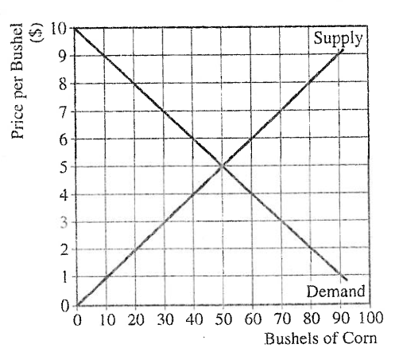

- Calculate the total revenue earned by com farmers at the market equilibrium price. Show your work.
- In an attempt to assist com farmers, the government sets a $7 price floor on corn.
  - How many bushels of corn will be exchanged at the price floor?
  - Calculate the deadweight loss associated with the price floor. Show your work.
  - Assume the government agrees to buy the unsold quantity at $7. Calculate the producer surplus. Show your work.
  - Assume the price floor and the government buying program remain in effect. In addition, assume the demand for corn does not change. In the long run, will the quantity of com purchased by the government increase, decrease, or remain the same? Explain.

PART 4 – ESSAY (20 POINTS)

Analyze the economic impact of increasing the minimum wage in a country, considering its effects on employment levels, income inequality, business competitiveness, and overall economic growth.
Note: The essay must have an introduction, content and conclusions.

